Date/Location: | Program:
January 16/SM | Unconventional Challenge  We will be voting for:  Class Clown (Project makes you laugh or smile)  Cutest Couple (Designer combined the project materials with something in addition to knitting/crochet)  Best Dressed (Project that you’d love to wear)  Party Animal (Most creative and crazy use of project materials)
January 25/NM
February 8-11 | Yarn Crawl
February 20/SM | Crochet for Knitters  Bring G or H crochet hook and a small skein of worsted weight yarn
February 22/NM
March 15-18 | FYI - Tropical Weavers’ Guild Annual Meeting
March 20/SM | Take Knits & Purls to the Next Level (Round Robin)
March 22/NM
March 29 | Yarn Swap
April 17/SM | Garage Sale  Yarn-related only, including magazines and books
April 26/NM
May 15/SM | Surface Design
May 24/NM
May 31 | Yarn Swap
June 9 | World Wide Knit in Public Day
June 19/SM | Beading for Knitters (Round Robin)
June 28/NM
July 17/SM | Steeking without Fear
July 26/NM
August 21/SM | Weaving
August 23/NM
August 30 | Yarn Swap
September 14-16 | FYI - Fiber In
September 18/SM | Yarn Substitution and Combining Yarns
September 27/NM
October 16/SM | Gift Giving Show and Tell (one skein or less)
October 25/NM
November 29 | Yarn Swap
December 6 | Holiday Party
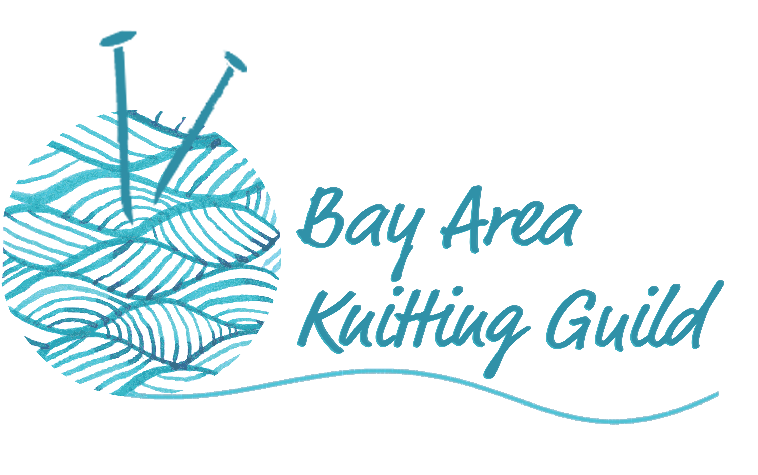
Calendar of Events - 2018

